Microservices with API Gateway - Assignment

MODULE 1: Creating Microservices for account and loan

Exercise 1: Account Microservice

Filename:
/account/src/main/java/com/cognizant/account/AccountApplication.java

Code:
package com.cognizant.account;

import org.springframework.boot.SpringApplication;
import org.springframework.boot.autoconfigure.SpringBootApplication;

@SpringBootApplication
public class AccountApplication {
public static void main(String[] args) {
SpringApplication.run(AccountApplication.class, args);
}
}

Controller:
/account/src/main/java/com/cognizant/account/controller/AccountController.java
package com.cognizant.account.controller;

import com.cognizant.account.model.Account;
import org.springframework.web.bind.annotation.*;

@RestController
@RequestMapping("/accounts")
public class AccountController {

@GetMapping("/{accountNumber}")
public Account getAccount(@PathVariable String accountNumber) {
return new Account(accountNumber, "savings", 234343);
}
}

Model:
/account/src/main/java/com/cognizant/account/model/Account.java
package com.cognizant.account.model;

public class Account {
private String number;
private String type;
private int balance;

public Account() {}

public Account(String number, String type, int balance) {
this.number = number;
this.type = type;
this.balance = balance;
}

public String getNumber() {
return number;
}

public void setNumber(String number) {
this.number = number;
}

public String getType() {
return type;
}

public void setType(String type) {
this.type = type;
}

public int getBalance() {
return balance;
}

public void setBalance(int balance) {
this.balance = balance;
}
}

application.properties:
spring.application.name=account
server.port=8081
eureka.client.service-url.defaultZone=http://localhost:8761/eureka

Sample Output:
Endpoint: http://localhost:8081/accounts/1234
Response:
{
"number": "12345",
"type": "savings",
"balance": 234343
}

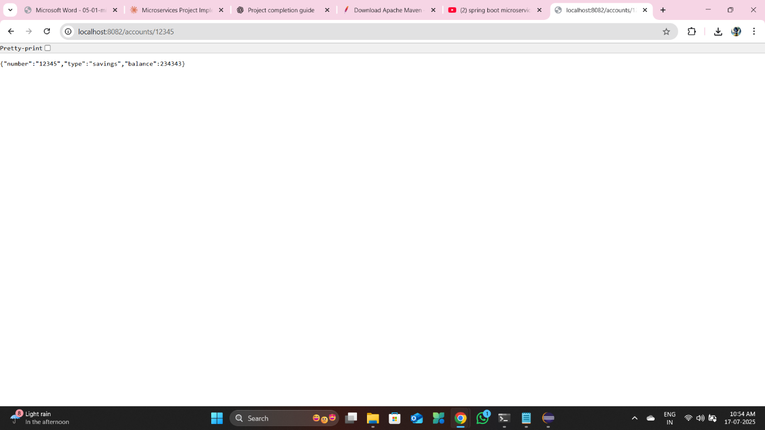

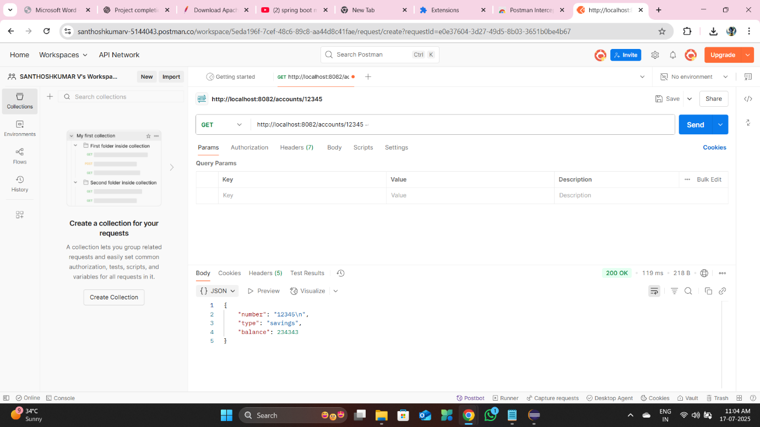

Exercise 2: Loan Microservice

Filename:
/loan/src/main/java/com/cognizant/loan/LoanServiceApplication.java

Code:
package com.cognizant.loan;

import org.springframework.boot.SpringApplication;
import org.springframework.boot.autoconfigure.SpringBootApplication;

@SpringBootApplication
public class LoanServiceApplication {
public static void main(String[] args) {
SpringApplication.run(LoanServiceApplication.class, args);
}
}

Controller:
/loan/src/main/java/com/cognizant/loan/controller/LoanController.java
package com.cognizant.loan.controller;

import com.cognizant.loan.model.Loan;
import org.springframework.web.bind.annotation.*;

@RestController
@RequestMapping("/loans")
public class LoanController {

@GetMapping("/{loanNumber}")
public Loan getLoan(@PathVariable String loanNumber) {
return new Loan(loanNumber, "personal", 50000);
}
}

Model:
/loan/src/main/java/com/cognizant/loan/model/Loan.java
package com.cognizant.loan.model;

public class Loan {
private String number;
private String type;
private int amount;

public Loan() {}

public Loan(String number, String type, int amount) {
this.number = number;
this.type = type;
this.amount = amount;
}

public String getNumber() {
return number;
}

public void setNumber(String number) {
this.number = number;
}

public String getType() {
return type;
}

public void setType(String type) {
this.type = type;
}

public int getAmount() {
return amount;
}

public void setAmount(int amount) {
this.amount = amount;
}
}

application.properties:
spring.application.name=loan
server.port=8083
eureka.client.service-url.defaultZone=http://localhost:8761/eureka

Sample Output:
Endpoint: http://localhost:8083/loans/98765
Response:
{
"number": "98765",
"type": "personal",
"amount": 50000
}

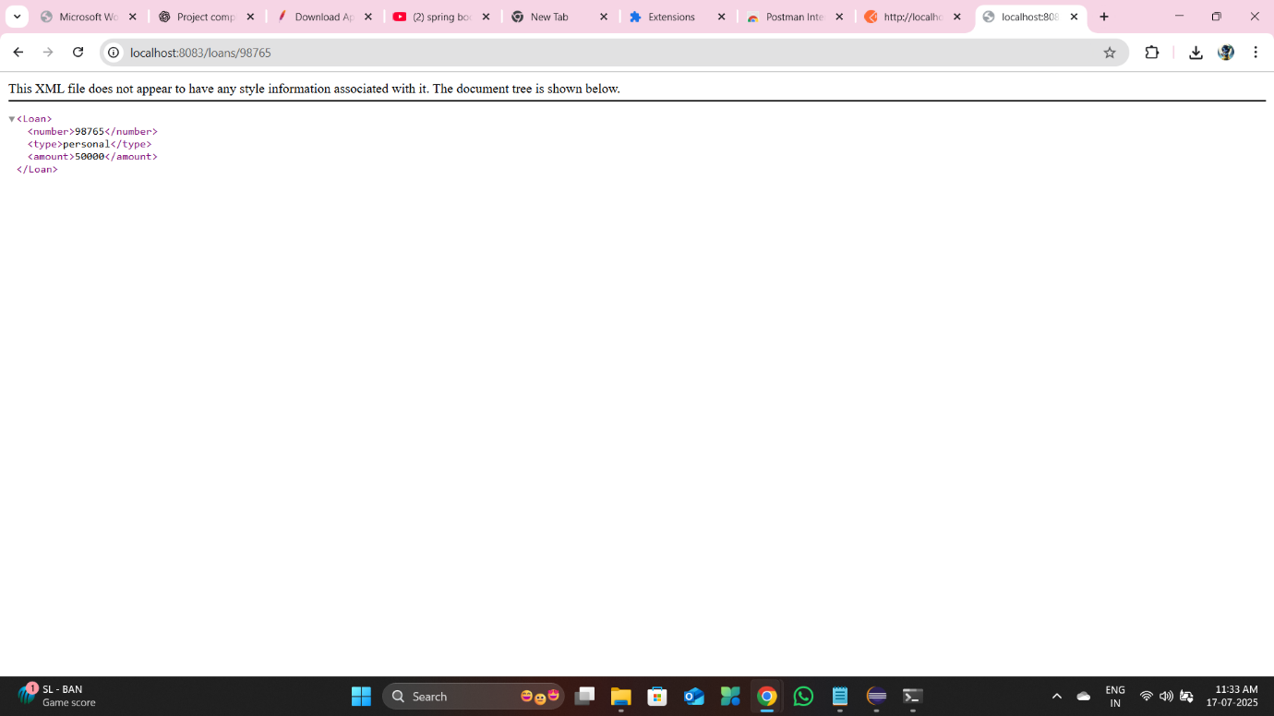

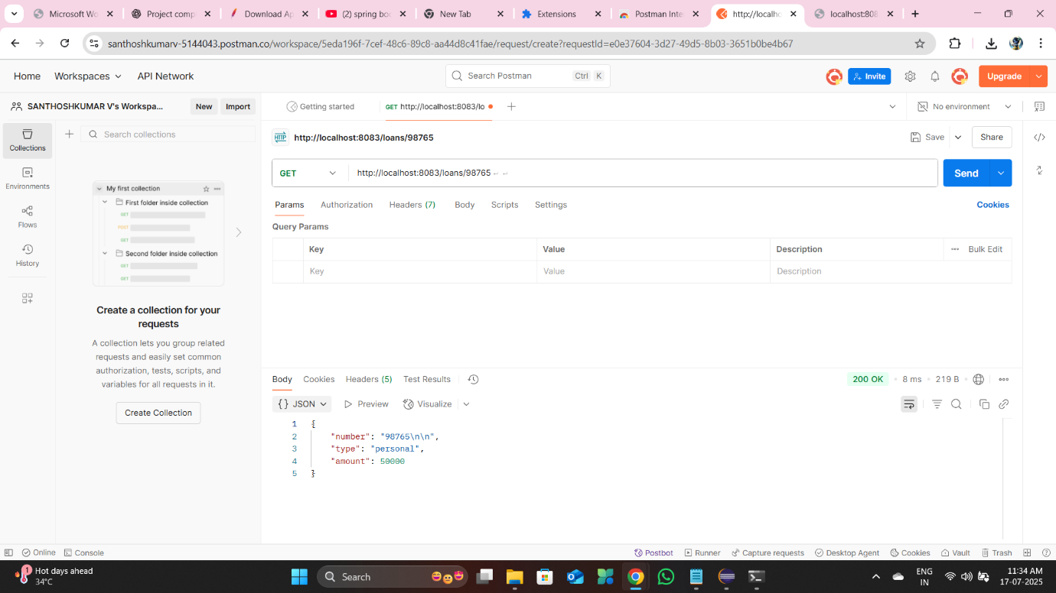

MODULE 2: Create Eureka Discovery Server and register

Exercise 1: Discovery Server Setup

Filename:
/discovery-server/src/main/java/com/cognizant/discoveryserver/DiscoveryServerApplication.java

Code:
package com.cognizant.discoveryserver;

import org.springframework.boot.SpringApplication;
import org.springframework.boot.autoconfigure.SpringBootApplication;
import org.springframework.cloud.netflix.eureka.server.EnableEurekaServer;

@SpringBootApplication
@EnableEurekaServer
public class DiscoveryServerApplication {
public static void main(String[] args) {
SpringApplication.run(DiscoveryServerApplication.class, args);
}
}

application.properties:
spring.application.name=discoveryserver
server.port=8761
eureka.client.register-with-eureka=false
eureka.client.fetch-registry=false

Sample Output:
Open http://localhost:8761 in browser.
You will see:
Eureka Dashboard - listing registered services
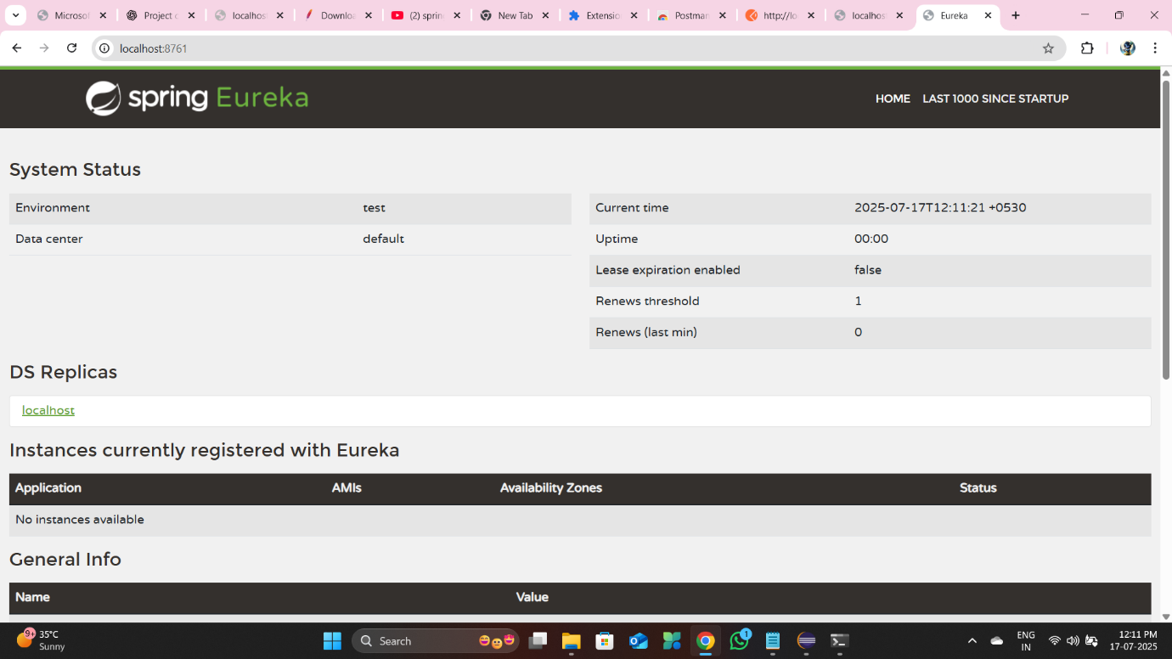
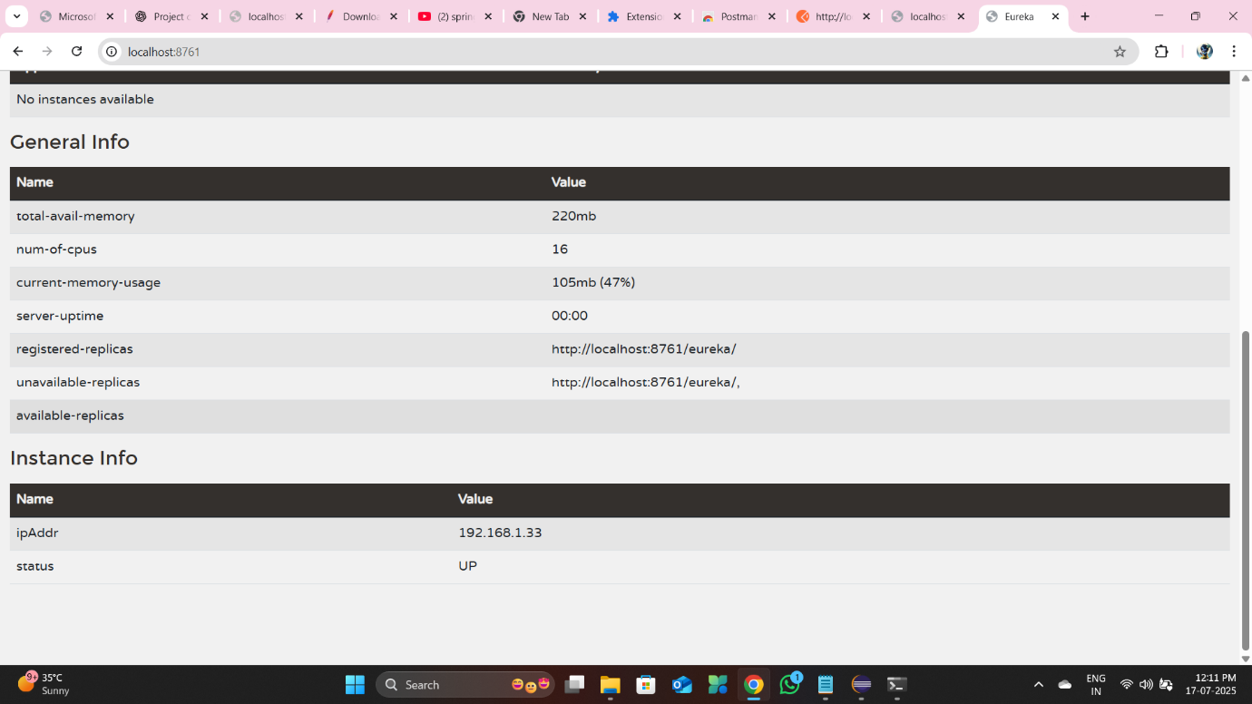
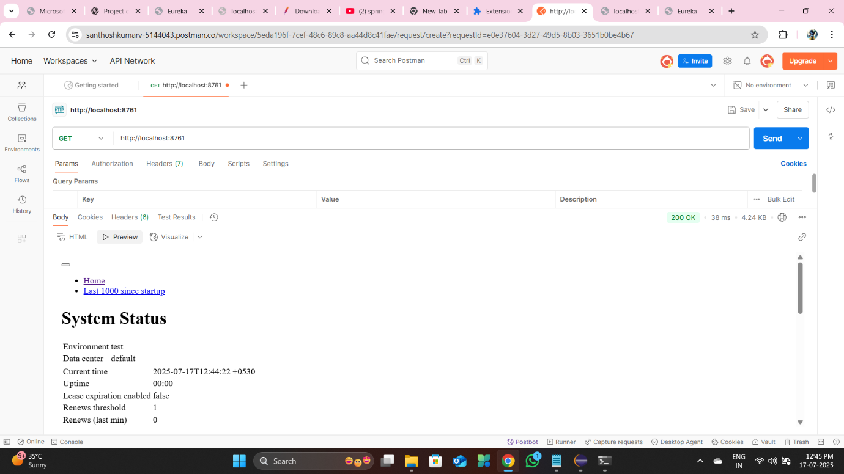
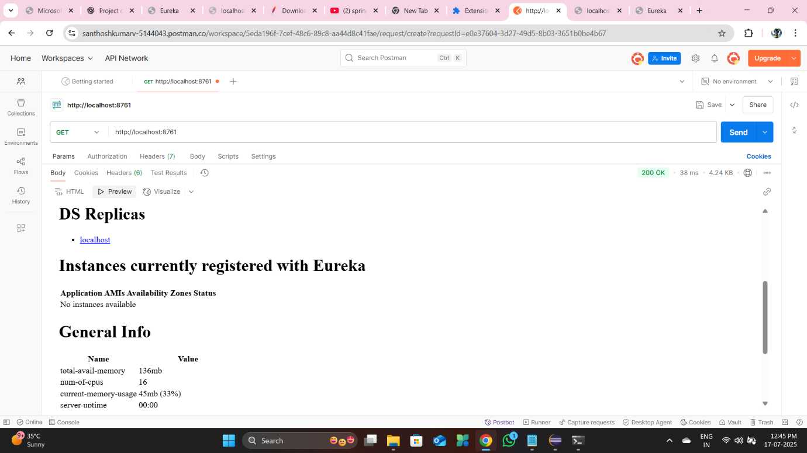

Exercise 2: Account Microservice(Register)

Filename:
/account/src/main/java/com/cognizant/account/AccountApplication.java

Code:
package com.cognizant.account;

import org.springframework.boot.SpringApplication;
import org.springframework.boot.autoconfigure.SpringBootApplication;
import org.springframework.cloud.netflix.eureka.server.EnableEurekaServer;

@SpringBootApplication
@EnableEurekaServer
public class AccountApplication {
public static void main(String[] args) {
SpringApplication.run(AccountApplication.class, args);
}
}

Controller:
/account/src/main/java/com/cognizant/account/controller/AccountController.java
package com.cognizant.account.controller;

import com.cognizant.account.model.Account;
import org.springframework.web.bind.annotation.*;

@RestController
@RequestMapping("/accounts")
public class AccountController {

@GetMapping("/{accountNumber}")
public Account getAccount(@PathVariable String accountNumber) {
return new Account(accountNumber, "savings", 234343);
}
}

Model:
/account/src/main/java/com/cognizant/account/model/Account.java
package com.cognizant.account.model;

public class Account {
private String number;
private String type;
private int balance;

public Account() {}

public Account(String number, String type, int balance) {
this.number = number;
this.type = type;
this.balance = balance;
}

public String getNumber() {
return number;
}

public void setNumber(String number) {
this.number = number;
}

public String getType() {
return type;
}

public void setType(String type) {
this.type = type;
}

public int getBalance() {
return balance;
}

public void setBalance(int balance) {
this.balance = balance;
}
}

application.properties:
spring.application.name=account
server.port=8081
eureka.client.service-url.defaultZone=http://localhost:8761/eureka

Sample Output:
Endpoint: http://localhost:8081/accounts/1234
Response:
{
"number": "12345",
"type": "savings",
"balance": 234343
}





Exercise 3: Loan Microservice (Register)

Filename:
/loan/src/main/java/com/cognizant/loan/LoanServiceApplication.java

Code:
package com.cognizant.loan;

import org.springframework.boot.SpringApplication;
import org.springframework.boot.autoconfigure.SpringBootApplication;
import org.springframework.cloud.netflix.eureka.server.EnableEurekaServer;

@SpringBootApplication
@EnableEurekaServer
public class LoanServiceApplication {
public static void main(String[] args) {
SpringApplication.run(LoanServiceApplication.class, args);
}
}

Controller:
/loan/src/main/java/com/cognizant/loan/controller/LoanController.java
package com.cognizant.loan.controller;

import com.cognizant.loan.model.Loan;
import org.springframework.web.bind.annotation.*;

@RestController
@RequestMapping("/loans")
public class LoanController {

@GetMapping("/{loanNumber}")
public Loan getLoan(@PathVariable String loanNumber) {
return new Loan(loanNumber, "personal", 50000);
}
}

Model:
/loan/src/main/java/com/cognizant/loan/model/Loan.java
package com.cognizant.loan.model;

public class Loan {
private String number;
private String type;
private int amount;

public Loan() {}

public Loan(String number, String type, int amount) {
this.number = number;
this.type = type;
this.amount = amount;
}

public String getNumber() {
return number;
}

public void setNumber(String number) {
this.number = number;
}

public String getType() {
return type;
}

public void setType(String type) {
this.type = type;
}

public int getAmount() {
return amount;
}

public void setAmount(int amount) {
this.amount = amount;
}
}

application.properties:
spring.application.name=loan
server.port=8083
eureka.client.service-url.defaultZone=http://localhost:8761/eureka

Sample Output:
Endpoint: http://localhost:8083/loans/98765
Response:
{
"number": "98765",
"type": "personal",
"amount": 50000
}





How to Run Each Module

1. Start Eureka Discovery Server
cd discovery-server
mvn clean install
java -jar target/discovery-server-0.0.1-SNAPSHOT.jar

2. Start Account Service
cd account
mvn clean install
java -jar target/account-0.0.1-SNAPSHOT.jar

3. Start Loan Service
cd loan
mvn clean install
java -jar target/loan-0.0.1-SNAPSHOT.jar

Note:
Ensure ports 8761, 8081, and 8083 are free.
if not kill the task with the help this command
D:\microservices\account>netstat -ano | findstr :8082
TCP 0.0.0.0:8082 0.0.0.0:0 LISTENING 11332
TCP [::]:8082 [::]:0 LISTENING 11332
D:\microservices\account>taskkill /PID 11332 /F

Initial State
Eureka Dashboard: No services registered.



Postman Dashboard: No endpoints tested.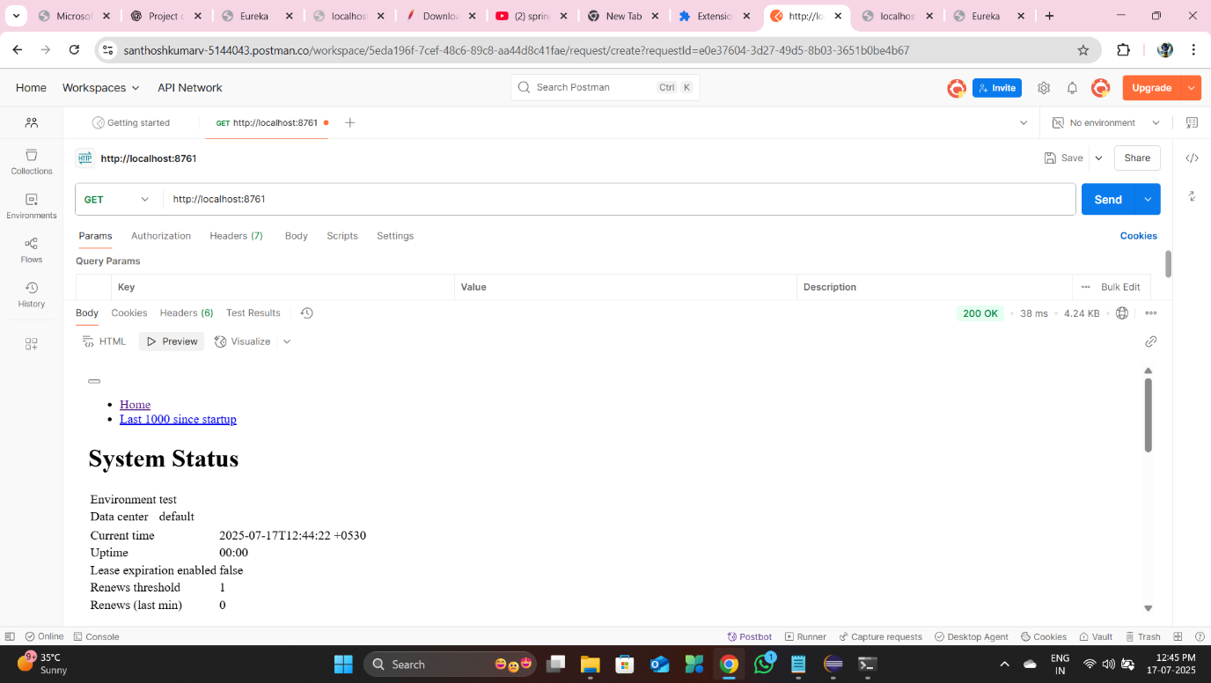

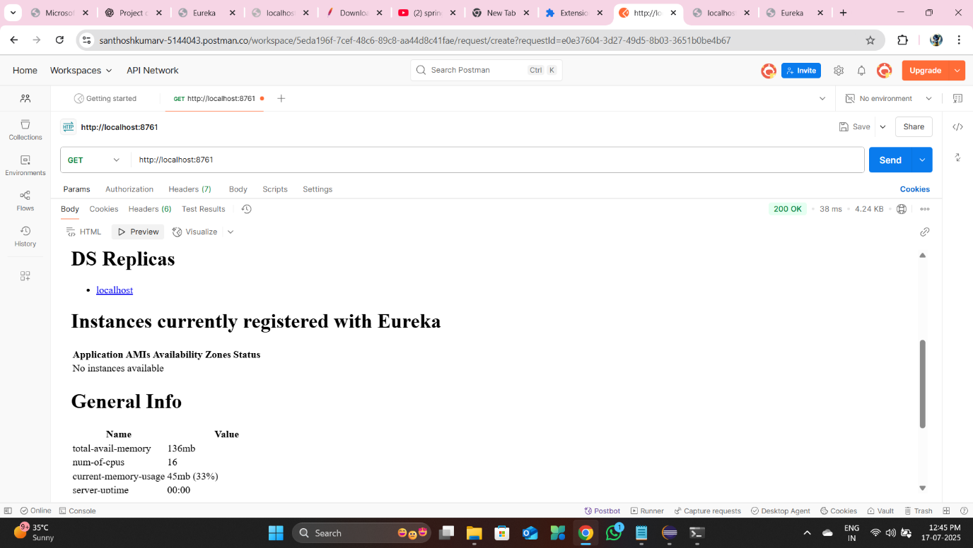

After Starting Account Service
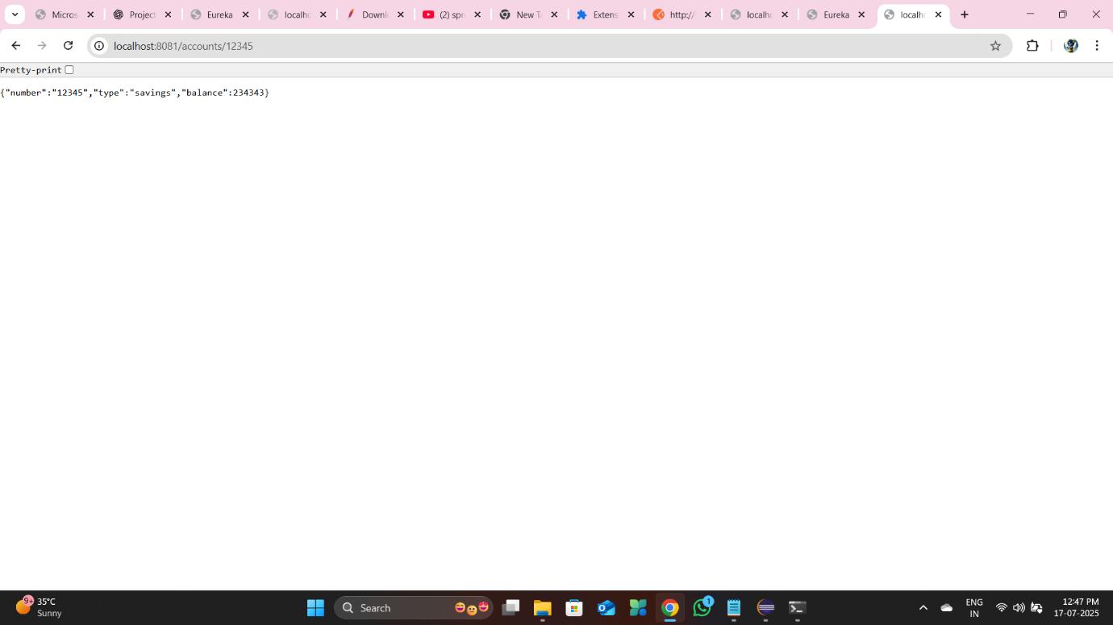

Eureka Dashboard: The Account Service is registered and visible.

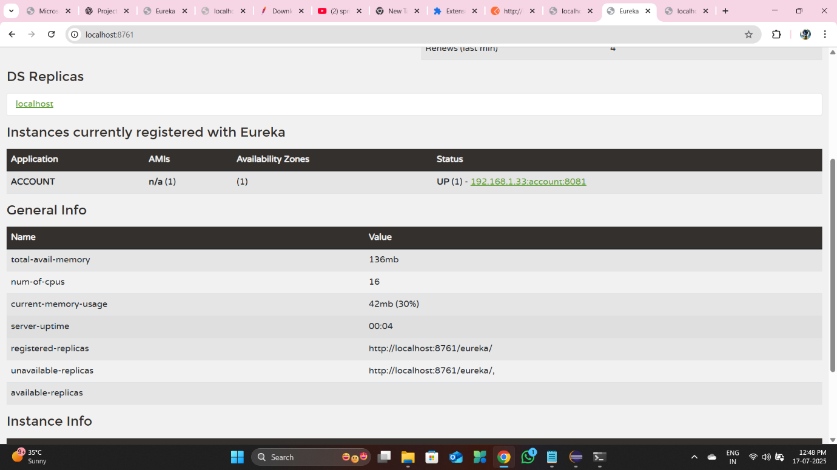
Postman: The /accounts/{accountNumber} endpoint is functional and returns a successful response.

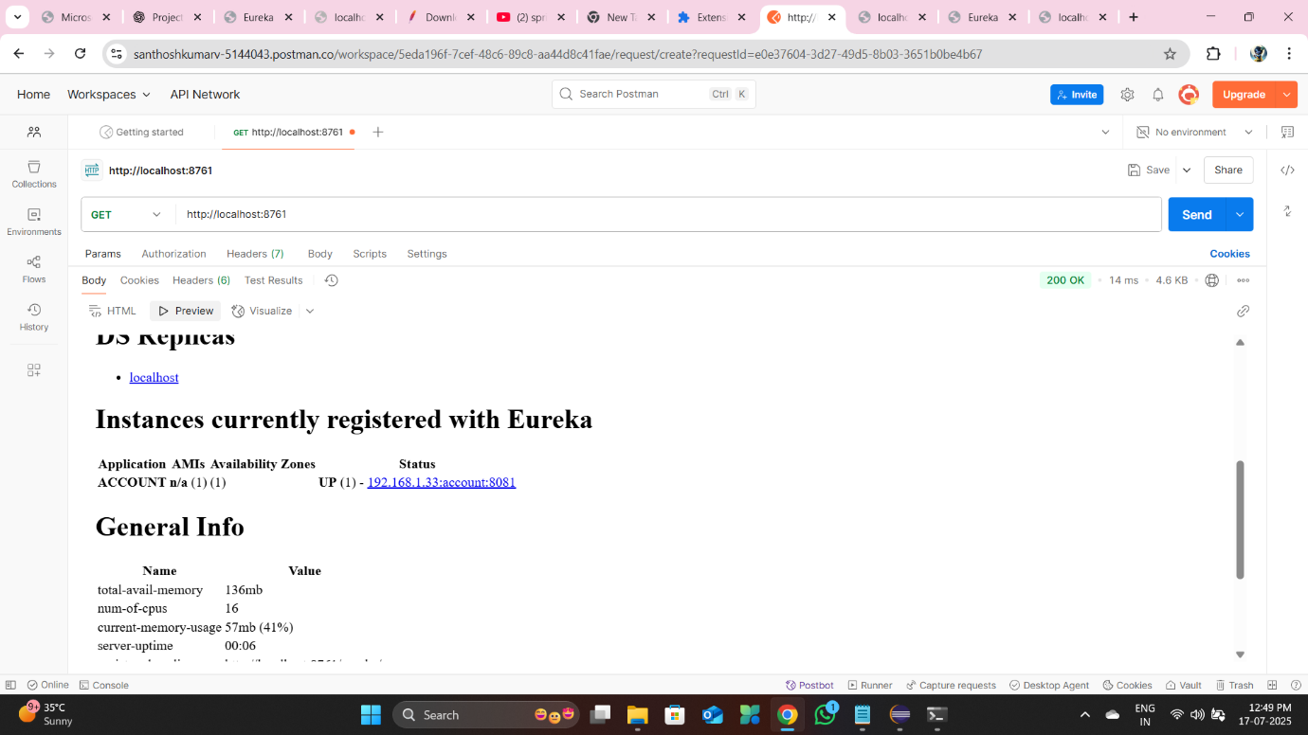

Account Service Running Only
Confirmed the isolation of the Account Service by stopping the Loan Service.
Eureka Dashboard: Only the Account Service remains registered.
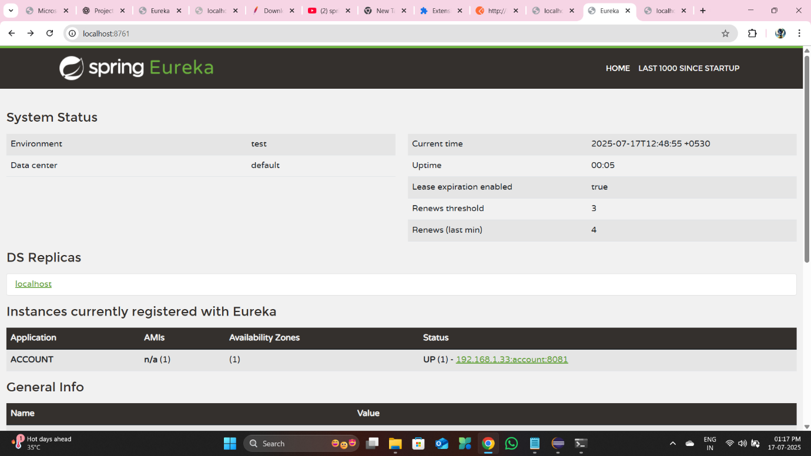
Postman: The /accounts/{accountNumber} endpoint continues to function.
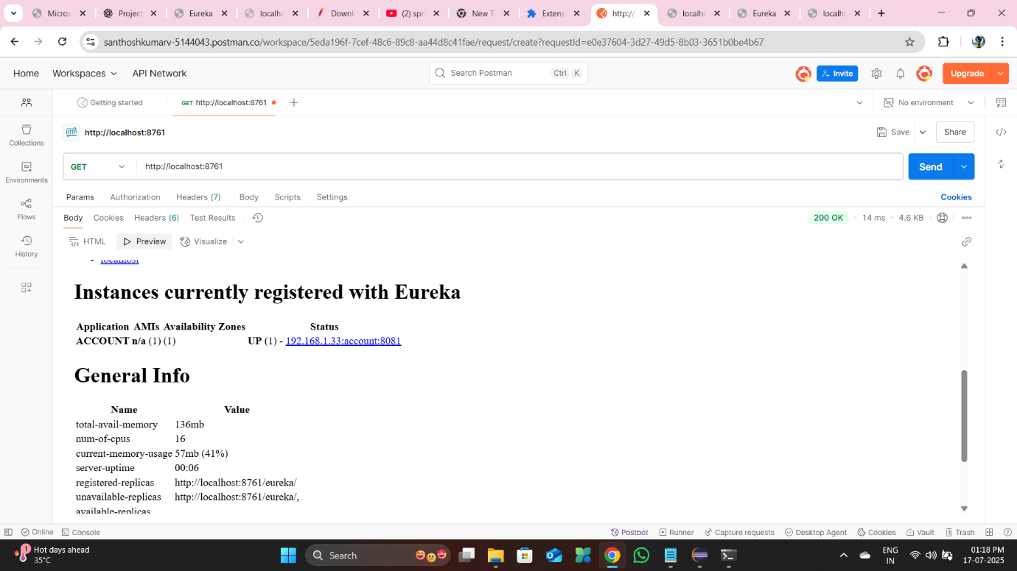

After Starting Loan Service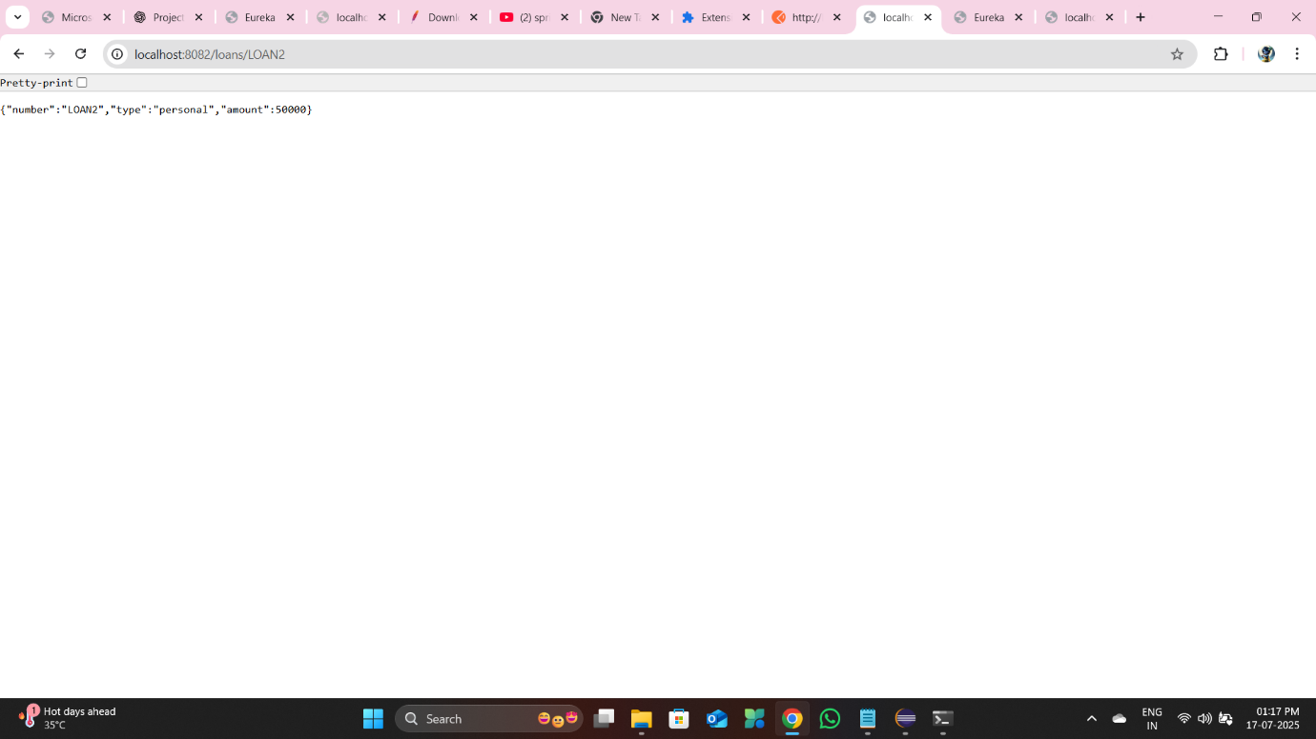
Eureka Dashboard: Both the Loan Service and Account Service are now registered.
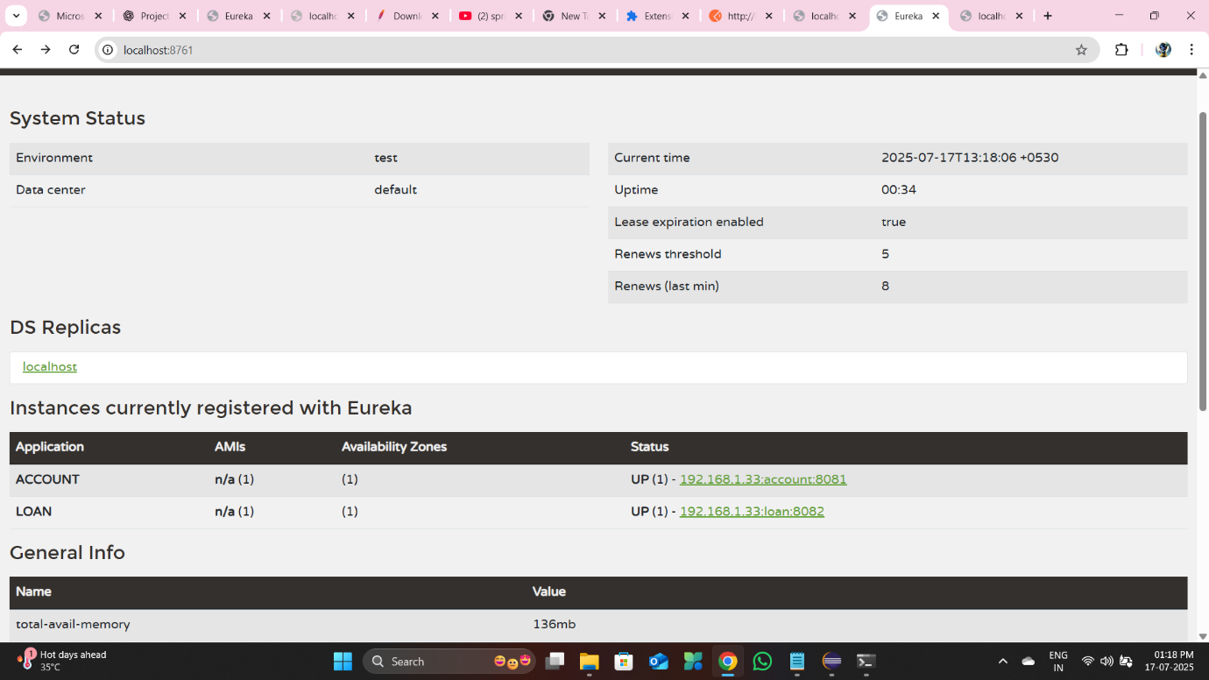
Postman: Both the /accounts/{accountNumber} and the Loan Service's corresponding endpoint are fully functional.